
Contents

- Get to Know Your Induction

- Get to Know Your Induction Milestones

- Making Sure People Get to Know You’re Here

- Get to Know the Borough

- Get to Know the Service

- Get to Know Your Workplace

- Get to Know about Health, Safety and Welfare

- Get to Know about Information Security

- Get to Know Your Conditions of Service

- Get to Know about Sickness Absence and Wellbeing

- Get to Know about Finance and Information Technology

- Get to Know about Workforce Development/Communication

- The Knowsley Better Together Journey

- Get to Know Your Team Specific/Workload Induction

- Get to Know and Reflect

- Get to Know the Induction Policy Checklist

- Get to Know a Sample Induction Calendar
- Get to know your induction

The Council places a great deal of emphasis on induction for all new employees, as well as those who transfer Services or are promoted, particularly when they become a manager or supervisor for the first time. In the early days and weeks of any new job, employees need to feel supported, valued and equipped with the necessary skills and knowledge to make a contribution to the work of the organisation as soon as possible.

There is a lot to learn about Knowsley, about the department and team, the role and the people around us. If you have started a new job within the Service your induction will include these key elements:

- Start Appointment letter with Information for New Employees
- Discussing and completing relevant elements of this Get to Know Knowsley booklet
- Attending the Knowsley Better Together Journey
- My Time and My Time Extra employee-led engagement process [See the My Time site on Bertha for more information]
- Service specific induction which focuses on introducing you to your service and your team and all the specific aspects of your job. (Individual service managers are responsible for picking this up with the employee)

You should experience these elements of your induction within 3 months of your start and can be undertaken in parallel with each other.

Bertha (the Council’s intranet site) also includes some useful guidance for new starters. Go to Staff Stuff>Your Job>Induction and Probation.

The checklists contained in this workbook will help to make sure that you cover all the necessary aspects of settling into a new job. This will support you to perform well during your probationary period by giving opportunities, raise relevant questions and receive timely and appropriate feedback.

The Corporate Induction applies equally to ALL new employees to Knowsley Council including temporary staff, part time staff and shift workers. The checklist should also be used for existing employees who have moved job roles where it is thought to be relevant.

- Your induction should be completed within 3 month of starting your new role.
- You do not need to complete the different sections of this workbook in any particular order
- The checklists are not exhaustive and should only guide the discussion
- Not everything on the checklists will be relevant as some aspects will depend on your job role
- Your manager may delegate elements of your induction to other colleagues
- Your manager may ask you to research some elements of these checklists
- You and your manager are jointly responsible for the completion of your induction.

This workbook will help guide you through the entire induction process.

How to use this workbook

This workbook is designed for you and your manager to use as a checklist during the various stages of settling into your new role. Not everything in this booklet may apply to you, but we suggest that you discuss each section with your manager and decide which parts are relevant for your role. It may be particularly helpful to review it during your probationary reviews and My Time or My Time Extra conversations.

The workbook does not need to be returned to Employee Services, but you and your manager should keep hold of it as evidence of your Corporate Induction.

- Get to Know Your Induction Milestones

Discussion item | Date  scheduled | Date achieved
Information Security discussion and e-learning | Week 1
Probationary period – 4 week review | Week 4
The Knowsley Journey experience | Within 4 weeks
My Time and My Time Extra conversation | Within Week 6
Probationary period – 10 week review | Week 10
Probationary period – 16 week review | Week 16
Induction Checklists | Within 16 weeks
Add your own milestones here | Week
Add your own milestones here | Week
Add your own milestones here | Week
Add your own milestones here | Week
Add your own milestones here | Week
Add your own milestones here | Week

- Make Sure People Get to Know You’re Here

When you start a new job it’s half the battle if people know you’re here. We have listed some of the tasks you and your manager need to complete to make sure the rest of the team knows about your arrival.

Discussion Item | Action required | Task completed
Staff directory updated:
Security passes and ID arranged:
Fire marshal informed:
First aider informed:
IT issues resolved:
Workplace equipment in place:

- Get to Know the Borough

Below is a snapshot of the Borough of Knowsley, and some facts about Knowsley Council;

- Knowsley is one of 6 Local Authorities that comprise the Liverpool City Region (Others being Liverpool, Sefton, St Helens, Wirral and Halton)
- The Council provides a wide range of services and responsibilities that cover many aspects of people’s lives. Some services are provided through our partners.
- The better we know the requirements of Knowsley’s population and service users, particularly the most vulnerable and those in greatest need, the better able we are to target finite resources effectively. Knowsley is home to more than 3,700 businesses employing around 65,000 people
- The current population stands at around 146,000 in over 61,000 households
- There are 62,746 households in the Borough and a target of 8,000 new homes to be delivered by 2028
- There are 147,231 residents of which, 24,781 are aged 65+ and 36,000 residents are 0 – 19 year old.
- The demand for adult social care is expected to rise by an estimated increase of 34% by 2030.
- Newly refurbished town centres and rural areas
- The Council and the Knowsley Partnership have set out their long term vision for the Borough in the Strategy for Knowsley which is for Knowsley to be the ‘Borough of Choice’ by 2023
- The Council’s four priorities form part of the Corporate Plan and are as follows:
- A Sustainable Budget Strategy
- Sustainable Children’s Services
- Improvement in Adult’s Social Care
- Business Growth, Jobs and Housing

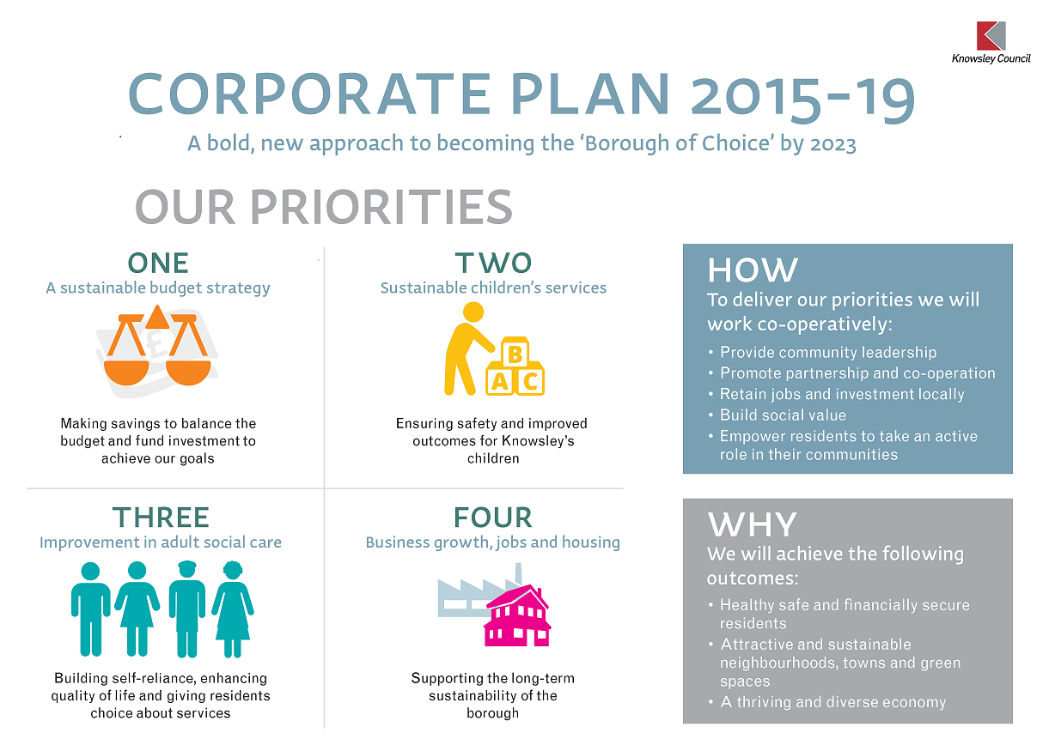

- Get to Know the Service

This checklist looks at where your role fits into the bigger picture. It can be a lot to take in at first but it is important to understand how you and your service contribute to the organisation. You and your manager should discuss these aspects and aim to complete this checklist within two weeks of your start date.

Discussion item | Tick when completed | Remarks
Structure of the Council and where your team fits in
Structure of the Service and where you fit in
Service planning, and how this links to your job role objectives
Where to go for further information
Who to speak to for further information
What to read for further information

- Get to Know Your Workplace

This part of your induction includes some of the basic information you need when you start a new job. You and your manager should discuss these items together and aim to complete this checklist on the first day of your new role.

Discussion Item | Tick when completed | Remarks
Tour of the work area
Introduction to key people
Location of toilets and kitchen
Car parking
Entrances and exits
Disabled access
Building Security
Refreshments and lunch
Local amenities
Your new contact number
Your new email address
Your new workplace address
Specific policies and protocols associated with your workplace

Structure of your team

Use the template below to enter your own team structure:

Assistant Executive Director

Sarah Smith___
Manager

______________
Colleague

______________

___________
Colleague

______________

____________
Colleague

______________

____________
Colleague

______________

____________
Colleague

______________

____________

Enter below details of partners of your team, both internal and external;
Agency/Service

______________

Agency/Service

______________
Agency/Service

______________

Agency/Service

______________

Agency/Service

_____________

Your Team

- Get to Know about Health, Safety and Welfare

The Council takes your health, safety and welfare very seriously. This section of your induction will help you understand our approach and your responsibilities. You and your manager should aim to complete this checklist within two weeks of your start date.

Discussion item | Tick when completed | Remarks
Health and Safety Policy
Employee responsibilities
Workplace fire marshal
Fire and bomb alerts/evacuation procedures
Reporting accidents and incidents
Work place first aiders and first aid kits
Risk Assessments & Suitable Control Measures
Notice boards
Health & Safety Training
VDU User - eyesight test provision
Smoking Policy
Occupational Health
Well-being at work activities
Counseling facilities
Protective clothing (if applicable)
Lone worker advice and guidance (if applicable)
Equipment handling (if applicable)
Mandatory training (if applicable)

- Get to Know about Information Security

The Council takes Data Protection and Information Security very seriously. This section of your induction will help you understand your responsibilities in helping ensure we keep personal information secure. You and your manager should aim to complete this checklist within two weeks of your start date and before you can have any access to any personal information.

Discussion item | Date completed | Remarks
Familiarise yourself with the ‘Corporate Information - Information Governance’ site on Bertha
Read and confirm you understand the Key Employee Responsibilities Document on BERTHA, ‘Corporate Information – Information Governance - Information Security – What it Means for You’
Read the Managing Conduct, Performance and Information Policy, specifically the following parts of the policy/appendices;
- Information Security Acceptable Use Policy
- Information Security Guidance Document
- Process for information security incidents
http://knowsley.learningpool.com/
- Complete KMBC Protecting Information 1 Online E-Learning
- Complete KMBC Protecting Information 2 Online E-Learning
Discuss whether further training is required

I confirm I have read all of the above information and understood my responsibilities in relation to information security.

Employee Signature ________________________________ Date ____________________________

- Get to Know Your Conditions of Service

This check list relates to your conditions of service. You and your manager should aim to complete this element of your induction within one month of your start date.

Discussion item | Tick when completed | Remarks
Job description and duties
Line management
Probationary period
Hours of work
Annual Leave
Flexible working
Authorised absence
Absence management procedures
Pay arrangements
Pension
Code of conduct and Knowsley Staff Qualities
Managing Conduct, Performance and Information Policy which covers:
- Disciplinary Procedure
- Capability Procedure
- Grievance Procedure
- Information Security
- Confidential reporting (whistle blowing)
Occupational Health & Wellbeing Policy which covers:
- Bullying and Harassment (Dignity at Work)
Career grades
Time management and lateness
Equality & Diversity Online Questionnaire (for employees who will be involved in the Recruitment & Selection Process as part of their role)
Process for claiming expenses e.g. mileage

For further information visit ‘Staff Stuff – Your Job’ on Bertha:

http://bertha.knowsley.gov.uk/Staff_Stuff/Your_job/Pages/default.aspx
The site is organised by subject:

- HR policies – provides a comprehensive list of policies and procedures relating to your job and human resources, including staff benefits and development
- Volunteering – provides information about the Council’s 'one approach' to volunteering and how you could get involved
- Stress Management – gives information about the causes and symptoms of stress and for strategies to help deal with it.
- Claims and expenses– tells you how you can claim expenses, including car mileage, meals rates and how you can claim your travel expenses electronically
- Schools' HR policies and procedures – provides a comprehensive list of policies and procedures relating to schools and school staff if this is applicable to you
- Employment terms and conditions – guidance for managers and information for staff on terms and conditions of employment for Knowsley Council employees.
- Health and Safety - find out about key health and safety contacts and get information about ensuring your personal safety in your day-to-day work.
- Pay and Grading Review - provides employees with information about the progress of the Pay and Grading Review is this still relevant?
- Recruitment and selection - helps you find out more about how we recruit staff and what procedure you should following if you are looking to recruit a new member of staff.
- My Time and My Time Extra – employee led engagement process.
- The Knowsley Better Together Journey – Council wide invitation to experience the history of Knowsley, past, present and future and how we will all be working Better Together
- Leaving the Council - If you're thinking about leaving the council, are coming up to retirement or are resigning, learn more about the procedures you need to follow.
- Trade Unions - Find information regarding trade union representation.
- Induction and Probation - If you are new to Knowsley Council, you will benefit from our induction programme to familiarise you with the organisation and the borough.
- Travelling to work - find out how you can save time, money and help save the environment with smarter ways of getting to work including cycling, public transport and car sharing
- Grievance and dignity at work – we all have a right to work without the fear of bullying or discrimination. Find out what you should do if you have an issue in your workplace.
- Maternity, paternity and adoption - by law, all staff are entitled to maternity and paternity leave when appropriate. Find out your rights and what you need to do if you are going to be a parent.
- Disciplinary and incapability – if you have conducted yourself badly in your job, have poor attendance or are not performing up-to-standard, you may be subject to a disciplinary procedure.
- Sickness absence and occupational health – this section contains forms and templates relating to sickness absence and occupational health issues.
- Employee Car Parking – find out about car parking charges for all users of public car parks in the borough’s town centres.
- Workforce planning - at its simplest, workforce planning is about assessing your future business needs and ensuring that you have the workforce to deliver.

- Get to Know about Sickness Absence and Wellbeing

The Council takes sickness absence very seriously. It is important that you know what to do if you are unwell. You and your manager should aim to complete this checklist within 2 weeks of your start date.

Discussion item | Tick when completed | Remarks
What to do if you are unwell:
- Who do you call?
- When do you call?
- Making the call yourself
What to do whilst you are off sick:
- Fit notes
- Keeping in contact
What will happen when you return to work
- Return to work interviews
- Sickness monitoring
Occupational Health
Unauthorised absence
Other absences

For further information about the Council’s sickness absence policy:

http://sharepoint.knowsley.gov.uk/sites/bertha/your-job/Human%20Resources/Pages/Human-Resources-Home-Page.aspx

- Get to Know about Finance and Information Technology

This checklist will help you understand the policies and procedures relating to finance and information technology. You and your manager should aim to complete this checklist within one month of your start date.

Discussion item | Tick when completed | Remarks
IT Policy
IT Security
Intranet Site
Sharepoint and IT storage
Staff directory
Email and internet
Financial procedures
Procurement
Petty cash
Gifts and hospitality
Prevention of fraud

For further information about the Council’s Information Technology policy:

http://bertha.knowsley.gov.uk/Staff_Stuff/Your_job/HRPolicies/Pages/eManagingConductPolicy.aspx

- Get to Know about Workforce Development/Communication

This checklist will help you understand more about Corporate Communications, Workforce Development and Learning and Development. You and your manager should aim to complete this checklist within one month of your start date.

Discussion item | Tick when completed | Remarks
My Time Extra annual conversation
My Time 8 weekly conversations
Supervision [where appropriate]
Our Time and Our Time Extra [Neighbourhood Services only – please check with your Line Manager]
Team meetings
Your learning and development priorities
Mandatory training
Job specific training
Team Briefing
Bertha communications i.e. Mike’s Blog and Ask the Chief Executive
Forthcoming staff events
Functional Skills Training

- The Knowsley Better Together Journey

The Knowsley Journey is an invitation to explore Knowsley past, present and future. It is an experiential session that all Knowsley Council staff will attend. As a new starter you should ensure you are booked onto the next available session. Speak to your manager about getting booked on.

Discussion item | Tick when completed | Remarks
The Knowsley Better Together Journey |  | Date of session:

- Get to Know your Team Specific/Workload Induction

This section of the induction will be populated by yourself and your line manager. You should include the following;
People I need to meet:

Places I need to visit:

Experiences I need to have:

Compliance I need to be aware of:

How I contribute to the Team Plan:

This links directly to your own Team Specific induction if there is one Ask your manager if there is any specific induction requirements for your service.

- Get to Know and Reflect

The Information for New Employees, Corporate Induction and Service Specific Induction should all be completed within 6 months of your start date. Use this opportunity to reflect on the first stage of your employment with Knowsley. Where applicable, this section should be used at the end of your probationary period.

Corporate Induction completed
Signed (employee) |  | Date
Signed (manager) |  | Date

Employee reflection and feedback

Manager reflection and feedback

- Get to Know the Induction Policy Checklist

Name of Employee

Please ask your manager to go through this list with you to ensure that these have all been discussed with you and you fully understand your responsibilities in relation to them and the possible implications if you fail to comply with them.

Here are some useful links below to the main policies in case you need to refer to them:
- HR Policies
- Health & Safety Policies
- Data Protection Policy
- Information Technology Policies

No | Policy/Procedure | Date Read/Discussed
1 | The council’s Code of Conduct and the Knowsley Staff Qualities
2 | At Risk – Redundancy & Redeployment Policy
3 | Consultation with Employees Policy
4 | Developing People Policy
5 | Flexible & Mobile Working Policy
6 | Occupation Health and Well-being Policy
7 | Managing Conduct, Performance & Information Policy
8 | Recruitment Policy
9 | Retirement & Pension Policy
10 | Sickness Absence Management Policy
11 | Time off Work Policy
12 | Information Security
13 | Knowsley Council Equality and Diversity Policy Statement, 2014 – 2016
14 | Equal Opportunities & Anti-discrimination
15 | Confidential Reporting (Whistle – Blowing)
16 | Health & Safety Policy Statement
17 | Risk Management Guidelines
18 | Accident Reporting
19 | Moving & Handling
20 | Access to Work Scheme
21 | Personal Safety and Lone Working
22 | Mobile Phones & Driving
23 | Smoking
24 | Alcohol and Illegal Substances
25 | Fire Safety, Bomb Threats
26 | Data Protection Policy

It is expected that managers review this checklist prior to the employee’s first PR&D
- Get to Know a Sample Induction Calendar

 |  | MON | TUES | WED | THU | FRI | SAT | SUN
Wk 1 | AM
Wk 1 | PM
Wk 2 | AM
Wk 2 | PM
Wk 3 | AM
Wk 3 | PM
Wk 4 | AM
Wk 4 | PM

